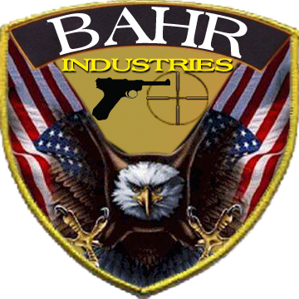
Certificate of Completion
Minnesota Personal Protection Act
I hereby certify that on this date that, _________________________________________
Has successfully completed the Minnesota Carry Permit Course, which includes; classroom instruction, rules of deadly force, handgun safety, training and qualification, and Minnesota carry laws.
__________________ _______ #83265076
Michael H Bahr Date NRA Cert #

