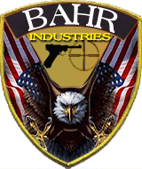
Certificate of Completion
Florida Chapter 790; Firearms Training
I hereby certify that on this date that, _________________________________________
Has successfully completed a four hour block of instruction given by an NRA Certified Instructor, which includes; classroom instruction, handgun safety, training; and a live fire shooting qualification.
__________________ _______ #83265076
Michael H. Bahr Date NRA Cert. No.

